

CSE421 (Computer Networks)

Project: Genome Assembly Research Network

Group: 1501
Team Members:
  - Afaf Binta Shamsuddin (ID: 22101844)
  - Dipannita Banik (ID: 24301043)
  - Syed Isfar Rahman (ID: 22201312)
  - MD. Aminul Islam Ornab (ID: 22101569)
Submission Date: XYZ

Topology:
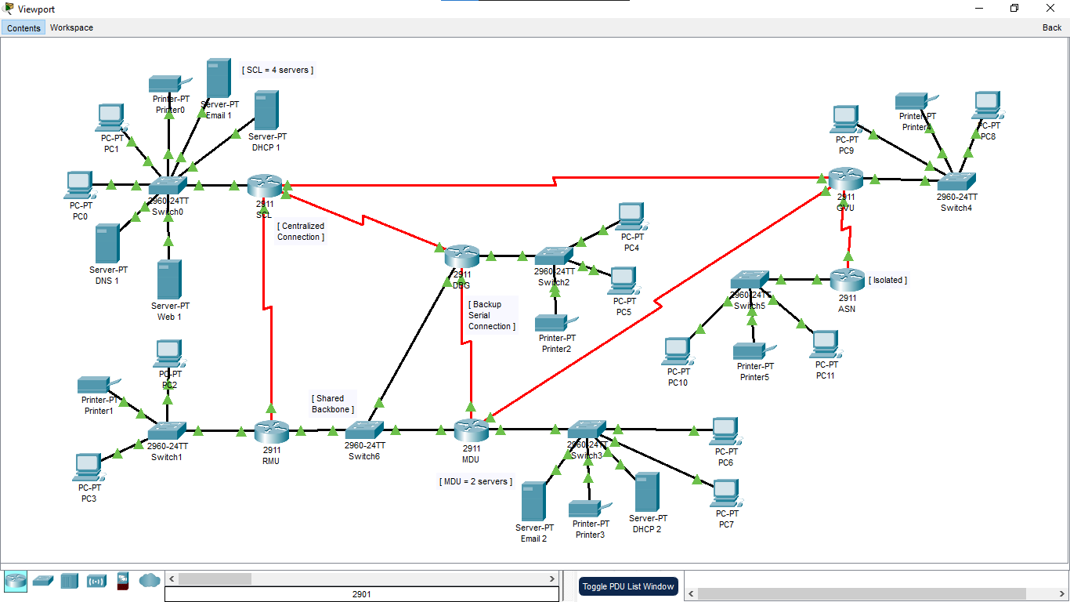

VLSM Tree: Base network – 69.44.0.0/16

LINK | Hosts | Network | Prefix | Mask | Usable range | Broadcast
SCL Lan | 520 | 69.44.0.0 | /22 | 255.255.252.0 | 69.44.0.1-69.44.3.254 | 69.44.3.255
RMU Lan | 300 | 69.44.4.0 | /23 | 255.255.254.0 | 69.44.4.1-69.44.5.254 | 69.44.5.255
DBG Lan | 220 | 69.44.6.0 | /24 | 255.255.255.0 | 69.44.6.1-69.44.6.254 | 69.44.6.255
MDU Lan | 160 | 69.44.7.0 | /24 | 255.255.255.0 | 69.44.7.1-69.44.7.254 | 60.44.7.255
GVU Lan | 90 | 69.44.8.0 | /25 | 255.255.255.128 | 69.44.8.1-69.44.8.126 | 69.44.8.127
ASN Lan | 45 | 69.44.8.128 | /26 | 255.255.255.192 | 69.44.8.129-69.44.8.190 | 69.44.8.191
Shared Backbone | 3 | 69.44.8.192 | /29 | 255.255.255.248 | 69.44.8.193-69.44.8.198 | 69.44.8.199
SCL-RMU | 2 | 69.44.8.200 | /30 | 255.255.255.252 | 69.44.8.201-69.44.8.202 | 69.44.8.203
SCL-DGB | 2 | 69.44.8.204 | /30 | 255.255.255.252 | 69.44.8.205-69.44.8.206 | 69.44.8.207
SCL-GVU | 2 | 69.44.8.208 | /30 | 255.255.255.252 | 69.44.8.209-69.44.8.210 | 69.44.8.211
DBG-MDU | 2 | 69.44.8.212 | /30 | 255.255.255.252 | 69.44.8.213-69.44.8.214 | 69.44.8.215
MDU-GVU | 2 | 69.44.8.216 | /30 | 255.255.255.252 | 69.44.8.217-69.44.8.218 | 69.44.8.219
GVU-ASN | 2 | 69.44.8.220 | /30 | 255.255.255.252 | 69.44.8.221-69.44.8.222 | 69.44.8.223

IP Addressing Table:

Network | Device | Interface | IP Address | Subnet Mask | Default Gateway
SCL LAN | SCL router | Gig0/0 | 69.44.0.1 | 255.255.252.0 | N/A
SCL LAN | Dns server |  | 69.44.0.2 | 255.255.252.0 | 69.44.0.1
SCL LAN | WEB Server |  | 69.44.0.3 | 255.255.252.0 | 69.44.0.1
SCL LAN | Email Server |  | 69.44.0.4 | 255.255.252.0 | 69.44.0.1
SCL LAN | DHCP Server1 |  | 69.44.0.5 | 255.255.252.0 | 69.44.0.1
SCL LAN | Printer |  | 69.44.0.6 | 255.255.252.0 | 69.44.0.1
SCL LAN | PC0 |  | 69.44.0.7 | 255.255.252.0 | 69.44.0.1
SCL LAN | PC1 |  | 69.44.0.8 | 255.255.252.0 | 69.44.0.1
RMU LAN | RMU Router |  | 69.44.4.1 | 255.255.254.0 | N/A
RMU LAN | Printer 1 |  | 69.44.4.2 | 255.255.254.0 | 69.44.4.1
RMU LAN | PC2 |  | 69.44.4.69 | 255.255.252.0 | 69.44.4.1
RMU LAN | PC3 |  | 69.44.4.70 | 255.255.252.0 | 69.44.4.1
DBG LAN | DGB router |  | 69.44.6.1 | 255.255.255.0 | N/A
DBG LAN | Printer2 |  | 69.44.6.2 | 255.255.255.0 | 69.44.6.1
DBG LAN | PC4 |  | 69.44.6.44 | 255.255.255.0 | 69.44.6.1
DBG LAN | PC5 |  | 69.44.6.45 | 255.255.255.0 | 69.44.6.1
MDU LAN | MDU Router |  | 69.44.7.1 | 255.255.255.0 | N/A
MDU LAN | Email Server |  | 69.44.7.2 | 255.255.255.0 | 69.44.7.1
MDU LAN | DHCP Server2 |  | 69.44.7.3 | 255.255.255.0 | 69.44.7.1
MDU LAN | Printer 3 |  | 69.44.7.4 | 255.255.255.0 | 69.44.7.1
MDU LAN | PC6 |  | 69.44.7.5 | 255.255.255.0 | 69.44.7.1
MDU LAN | PC7 |  | 69.44.7.6 | 255.255.255.0 | 69.44.7.1
GVU LAN | GVU router |  | 69.44.8.1 | 255.255.255.128 | N/A
GVU LAN | Printer4 |  | 69.44.8.2 | 255.255.255.128 | 69.44.8.1
GVU LAN | PC8 |  | 69.44.0.5 | 255.255.255.128 | 69.44.8.1
GVU LAN | PC9 |  | 69.44.0.5 | 255.255.255.128 | 69.44.8.1
ASN LAN | ASN Router |  | 69.44.8.129 | 255.255.255.192 | N/A
ASN LAN | Printer 5 |  | 69.44.8.130 | 255.255.255.192 | 69.44.8.129
ASN LAN | PC10 |  | 69.44.8.131 | 255.255.255.192 | 69.44.8.129
ASN LAN | PC11 |  | 69.44.8.132 | 255.255.255.192 | 69.44.8.129
Backbone IP address | RMU Router |  | 69.44.8.193 | 255.255.255.248 | N/A
Backbone IP address | DBG Router |  | 69.44.8.194 | 255.255.255.248 | N/A
Backbone IP address | MDU Router |  | 69.44.8.195 | 255.255.255.248 | N/A
SCL-RMU wan | SCL Router |  | 69.44.9.1 | 255.255.255.252 | N/A
 | RMU Router |  | 69.44.9.2 | 255.255.255.252 | N/A
SCL-DBG | SCL Router |  | 69.44.9.5 | 255.255.255.252 | N/A
 | DBG Router |  | 69.44.9.6 | 255.255.255.252 | N/A
SCL-GVU | SCL Router |  | 69.44.9.9 | 255.255.255.252 | N/A
 | GVU Router |  | 69.44.9.10 | 255.255.255.252 | N/A
MDU-GVU | MDU Router |  | 69.44.9.13 | 255.255.255.252 | N/A
 | GVU Router |  | 69.44.9.14 | 255.255.255.252 | N/A
GVU-ASN | GVU Router |  | 69.44.9.17 | 255.255.255.252 | N/A
 | ASN Router |  | 69.44.9.18 | 255.255.255.252 | N/A
DBG-MDU  BackUP | DBG ROUTER |  | 69.44.9.21 | 255.255.255.252 | N/A
 | MDU Router |  | 69.44.9.22 | 255.255.255.252 | N/A

